Lick4valve Teensy 3.2 board V1

Xavier Cano-Ferrer, George Konstantinou

The Making STP, The Francis Crick Institute

This piece of hardware is a Teensy 3.2 [1] breakout board with 4 valve controls and (capacitive) licking sensors and with the same amount of digital inputs/outputs (8 in total). This device pretends to be a tool for behavioural experiments which need to control up to four valves and sense 4 licking sensors. The board has eight digital pins with interrupt capability. These pins are connected to a BNC and they can be used to display digital signals or to trigger externally the valves for instance. The Teensy 3.2 performs very well on the capacitive sensor library [2] achieving sub-millisecond sampling periods while using one licking sensor at 120 MHz clock speed. All thought the licking frequency in mice is ~7 Hz, sub-millisecond resolution is required when accurate sensing of lick onset and offset is desired [3].

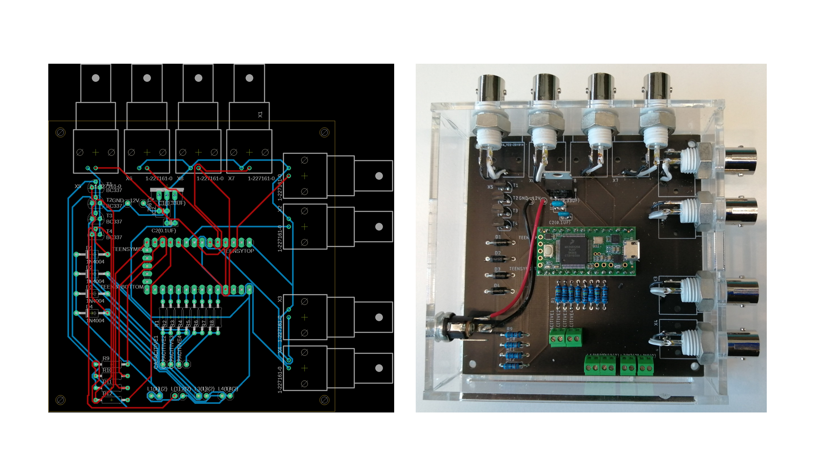

Figure 1: Lick4valve Teensy 3.2 board.

R1-R8 resistor values (Capacitive sensor pins resistors)

The value of the capacitive sensor emitter is 1MΩ and the receiver digital pin has a 1kΩ resistance value to avoid an accidental electric shock [5]. The value of the high resistance value resistor can be changed to higher values in order to increase sensitivity.

R9-R12 Calculation example (Transistor base)

The solenoid valve used for the design is the Lee company model LHDA0533215H. The current needed on the transistor collector has been calculated using the power and the resistance from the manufacturer specifications [4].

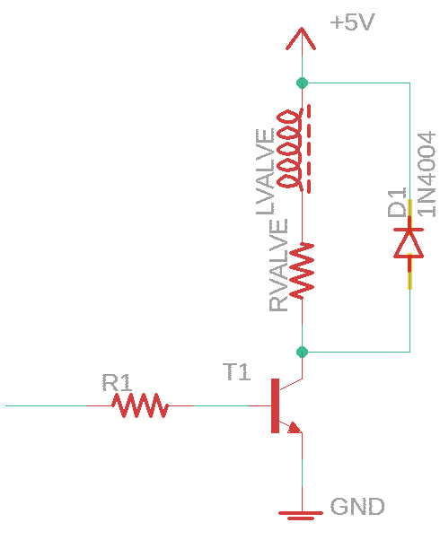

$P_{valve}=550 mW$ $R_{valve}=46 Ω$

$$P_{valve}=I_{valve}^{2}*R_{valve}$$

$$I_{valve}=\sqrt{\frac{P_{valve}}{R_{valve}}}=\sqrt{\frac{550 mW}{46 Ω}}$$

$$I_{valve}=109 mA$$

*BC 337 NPN Transistor*

$$h_{FE}=100 I_{C}=100mA V_{CE(ON)}=1.2V$$

$$I_{B}=\frac{I_{C}}{h_{FE}}=\frac{100 mA}{100}=1mA$$

*BE mesh*

$$-TTL+I_{B}R+V_{CE(ON)}=0$$

$$-3.3V+(1 mA)R+1.2V=0$$

$$R1=\frac{2.1V}{1mA}=2.1kΩ$$

*CE mesh*

$$-V_{cc}+R_{valve}I_{C}+V_{CE}=0$$

$$-3.3V+46Ω 100mA+V_{CE}=0$$

$$V_{CE}=1.3V$$

Bill of materials

**Table 1: Bill of materials**

|  |  |  |
| --- | --- | --- |
| **Component** | **Units** | **Reference** |
| PCB CAM documents | 1 | PCB files |
| Base | 1 | Enclosure DWG files |
| Cover | 1 | Enclosure DWG files |
| Lateral BNC | 1 | Enclosure DWG files |
| Lateral BNC + USB | 1 | Enclosure DWG files |
| Lateral connections | 1 | Enclosure DWG files |
| Lateral Power supply | 1 | Enclosure DWG files |
| Teensy 3.2 | 1 |  |
| Screw connector (Phoenix) | 6 | - |
| Female pin header | 1 | - |
| Barrel Jack connector | 1 | **-** |
| BNC wall connector | 8 | Enclosure DWG files |
| Flyback diode 1N4004 | 4 | - |
| Resistor 2.1k | 4 | **-** |
| Resistor 1k | 4 | **-** |
| Resistor 1M | 4 | **-** |
| LM7805 Linear voltage regulator | 1 | **-** |
| 330 nF ceramic capacitor | 1 | **-** |
| 100 nF ceramic capacitor | 1 | **-** |
| M3 Threaded inserts | 4 | **-** |
| Spacer | 4 | STL file |
| M3 screws | 8 | **-** |

Assembly instructions

Insert the M3 brass threaded inserts on the four spacers and attach the four spacers on the cover.

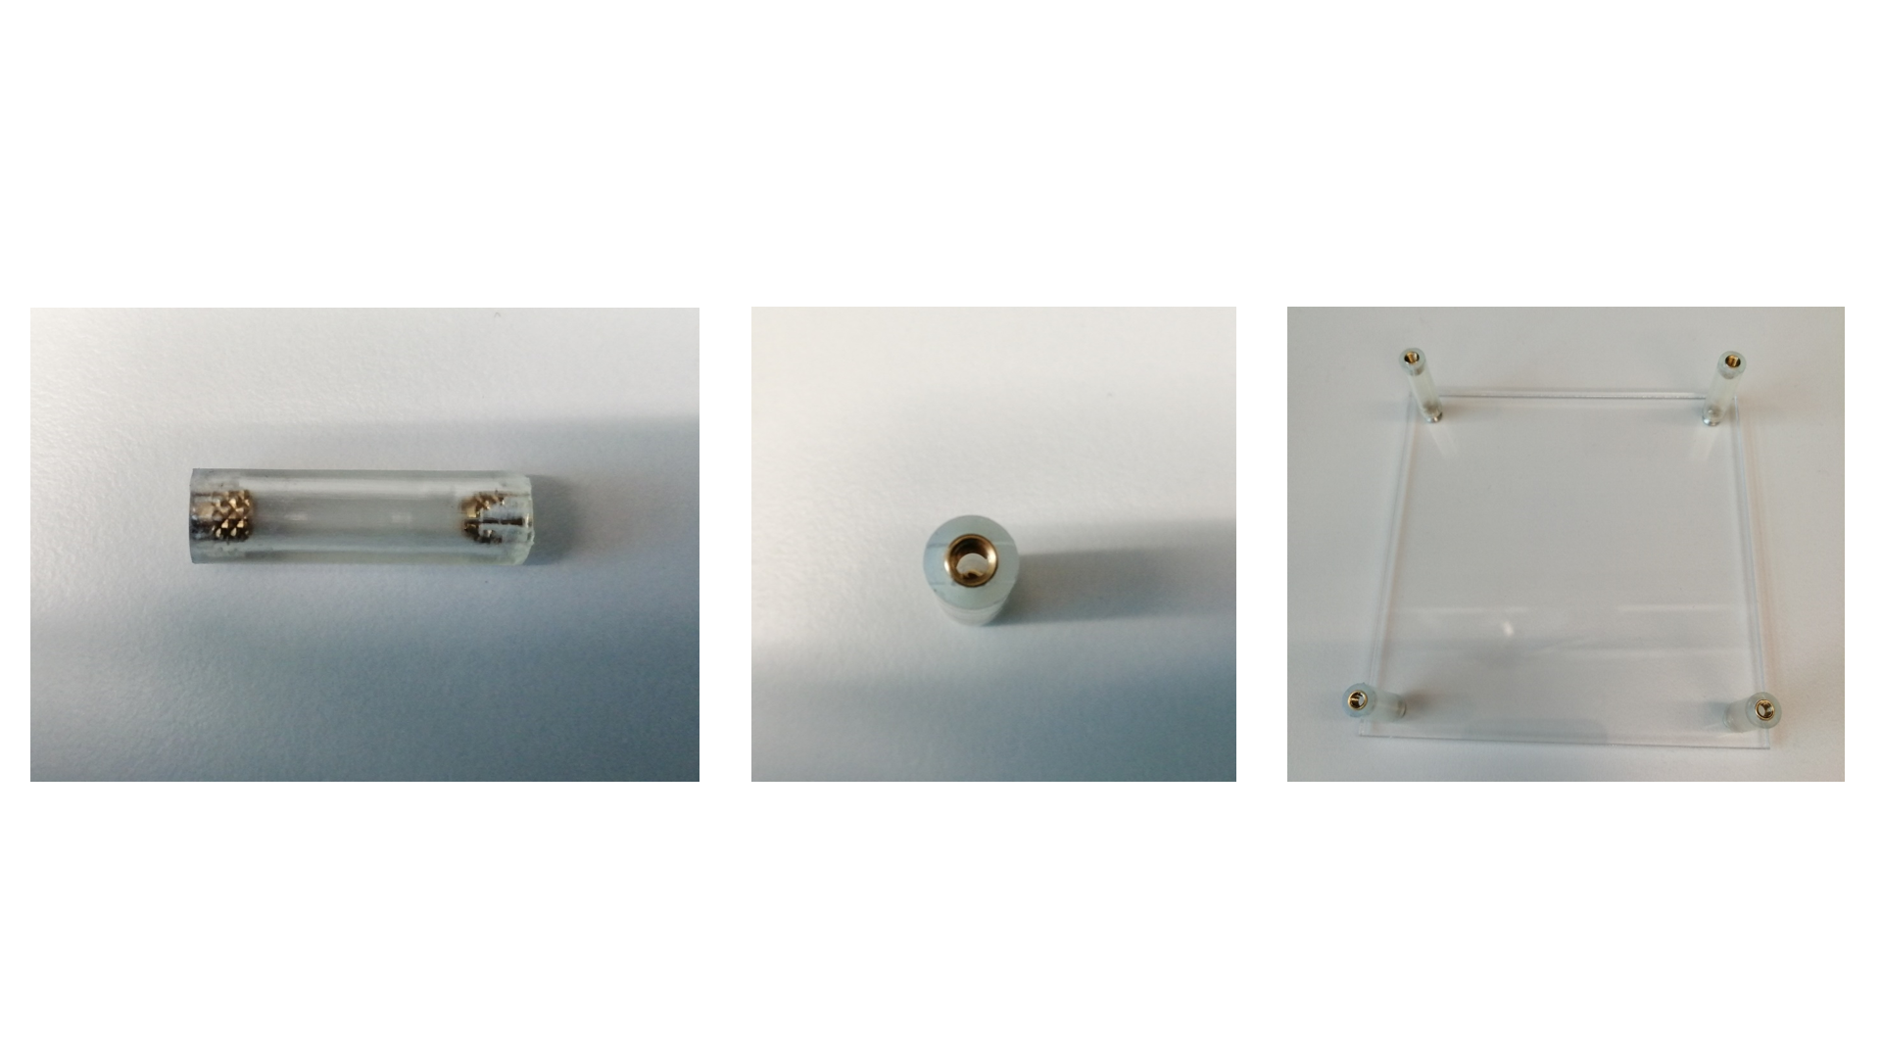

Laser cut the PMMA case components. Use UV curing glue to attach the five components of the box together.

Solder the Resistors, female pin headers, flyback diodes, capacitors, linear regulator, transistors and screw connectors and short cables for the signals and the 12V power supply connection. Then place the PCB inside the PMMA box and the BNC and barrel jack on their holes and solder the cables on their connectors.

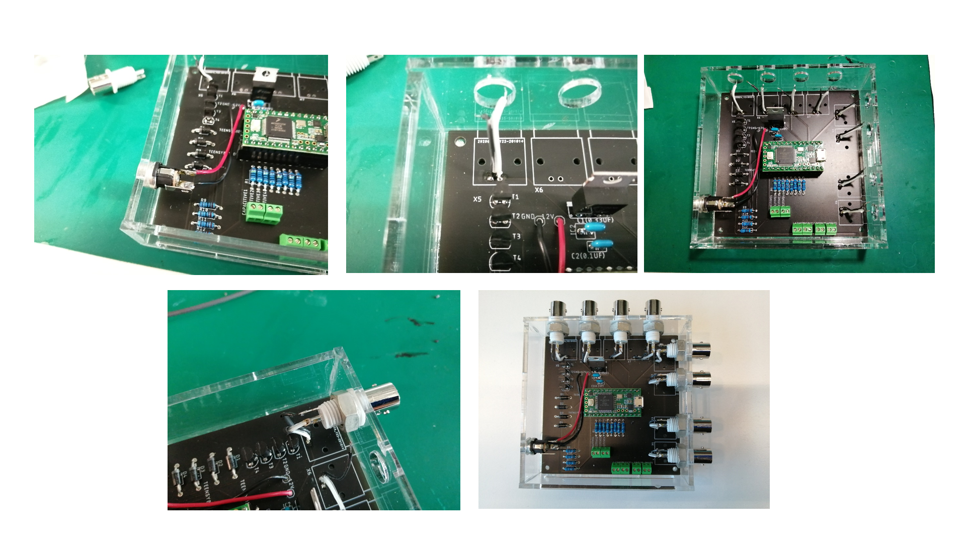

Connect the micro USB cable on the Teensy 3.2 USB port and upload the code.

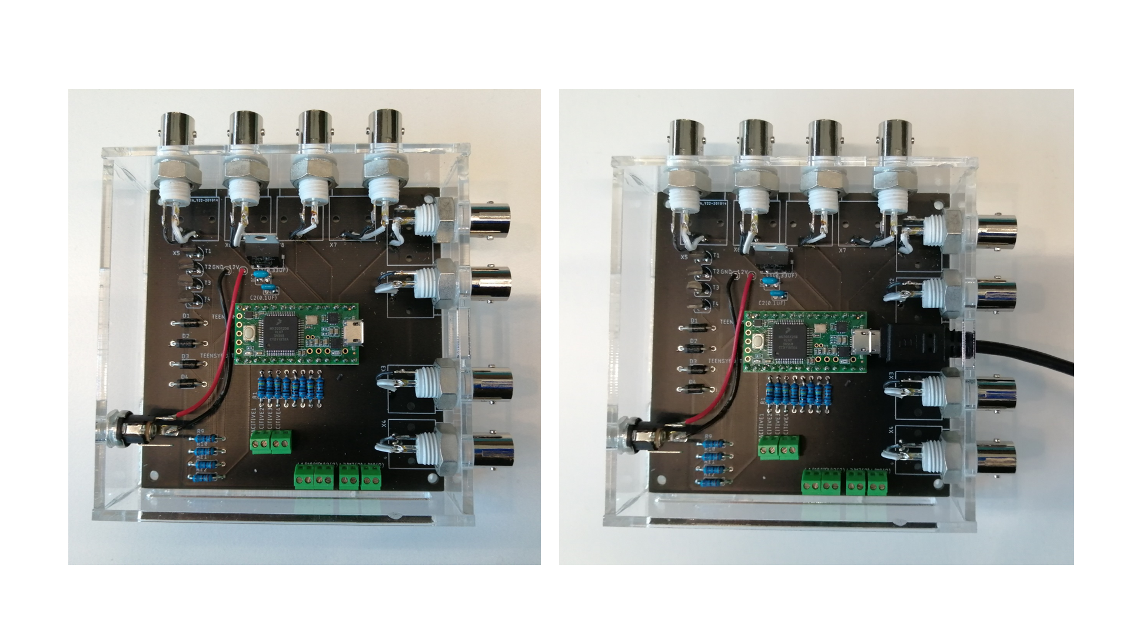

Example code

# References

|  |  |
| --- | --- |
| [1] | "https://www.pjrc.com/teensy/teensy31.html," [Online]. |
| [2] | "https://github.com/PaulStoffregen/CapacitiveSensor," [Online]. |
| [3] | B. Williams, A. Speed and B. Haider, "A novel device for real-time measurement and manipulation of licking behavior in head-fixed mice," *Journal of Neurophisiology,* vol. 120, pp. 2975-2987, 2018. |
| [4] | "https://www.theleeco.com/products/electro-fluidic-systems/solenoid-valves/control-valves/lhd-series/3-port/ported/," [Online]. |
| [5] | "https://www.pjrc.com/teensy/td_libs_CapacitiveSensor.html," [Online]. |